**Complex Engineering Problem**

**EE-450 High Voltage Engineering**

**Submitted to:**

Dr. Hira Tahir

**Submitted by:**

Ghulam Abbas 2018-EE-361

**Section:**

A

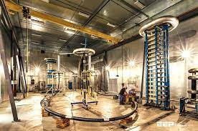

***University of Engineering and Technology Lahore, Faisalabad Campus***